Liste over relevante links til YouTubes

if-else (selektion)

<https://www.youtube.com/watch?v=9-BjXs1vMSc>

else-if (selektion)

<https://www.youtube.com/watch?v=cec5DV42wjI>

while (iteration)

<https://www.youtube.com/watch?v=iF4i423144E>

for (iteration)

<https://www.youtube.com/watch?v=yS8DUrQy_ow&t=19s>

do-while (iteration)

<https://www.youtube.com/watch?v=TjkJQly2YCw>

Ovenstående links er fra *Neso Academy* og jeg har følgende bemærkninger:

* Ikke enig i hans placering af krøllede parenteser.
* for og while-kontruktioner er 'interchangeable'.
* Jeg har sjældent haft brug for *while* (bortset fra *while(true)* ) og har kun ganske enkelte gange brugt *do-while;* men det er en ”temperaments-sag”. Find din egen stil og vær tro mod den.

Skrivning af klasser 1:

<https://www.youtube.com/watch?v=vz1O9nRyZaY>

Skrivning af klasser 2:

[https://www.youtube.com/watch?v=b9wialxvcV](https://www.youtube.com/watch?v=b9wialxvcVA)

Strings:

Traditionel

<https://www.youtube.com/watch?v=HP3oA5XmzvM>

Focus på nogle af string-klassens metoder:

<https://www.youtube.com/watch?v=mp7Um7k-G4I>

String-nørderi, inklusive CString og (manglende) sikkerhed i C-programmer

<https://www.youtube.com/watch?v=zo6B_eJmeLo&t=325s>

Arrays:

[Definition of Array - YouTube](https://www.youtube.com/watch?v=55l-aZ7_F24)

[Declaration of Array (youtube.com)](https://www.youtube.com/watch?v=Bqud0_ozgcc&t=102s)

[Accessing Array Elements (youtube.com)](https://www.youtube.com/watch?v=g0ClJ28-8LE)

[Initializing an Array (youtube.com)](https://www.youtube.com/watch?v=GtcRReso9Xk)

Stack og heap; memory allocation:

[C++ Objects: Stack vs. Heap (youtube.com)](https://www.youtube.com/watch?v=PCnDoknVFK4&t=168s)

[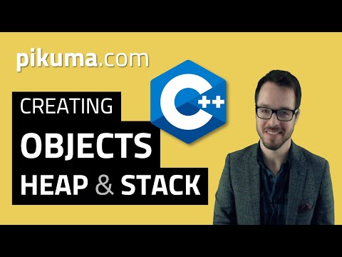](https://www.youtube.com/watch?v=PCnDoknVFK4&t=168s)

Lad jer ikke forvirre af, at det er en video i en serie om spiludvikling. Det betyder ikke noget. Problemstillingen er generel. Og så snakker han om *memory leaks,* som er det fænomen, at memory ikke bliver frigivet, efter at programmet er holdt op med at bruge det.

Pointere og referencer:

[What is the Difference Between a Pointer and a Reference C++ - YouTube](https://www.youtube.com/watch?v=sxHng1iufQE)

Vector – det oplagte alternativ til arrays:

<https://www.youtube.com/watch?v=RXzzE2wnnlo>

[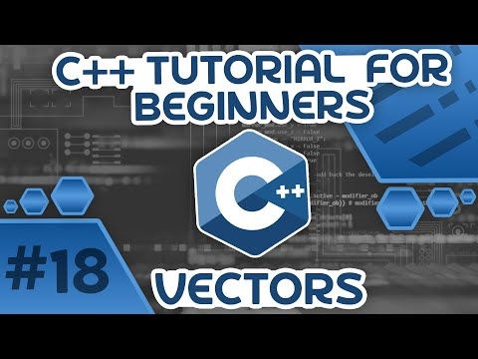](https://www.youtube.com/watch?v=RXzzE2wnnlo)

[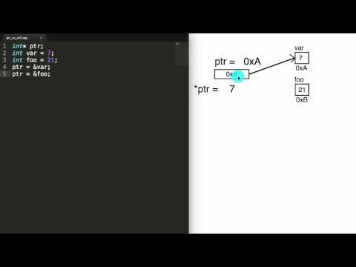](https://www.youtube.com/watch?v=sxHng1iufQE)

Call by value og call by reference:

[Call By Value & Call By Reference in C (youtube.com)](https://www.youtube.com/watch?v=HEiPxjVR8CU)

[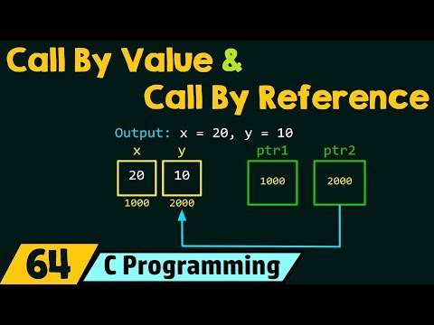](https://www.youtube.com/watch?v=HEiPxjVR8CU)

Smart pointers:

[Smart Pointers in C++ (Stop Using new?) (youtube.com)](https://www.youtube.com/watch?v=x_eHJmdGQ_4)

[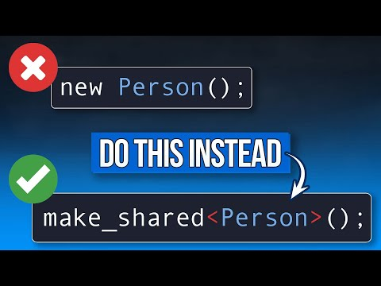](https://www.youtube.com/watch?v=x_eHJmdGQ_4)

Grundlæggende input/output cin og cout:

[Input and Output in C++ (youtube.com)](https://www.youtube.com/watch?v=1Wrc91mp980&t=661s)

[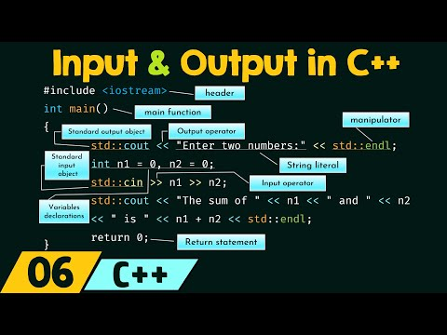](https://www.youtube.com/watch?v=1Wrc91mp980&t=661s)

Output file streams i C++

[Output File Streams in C++ (Writing to Files) (youtube.com)](https://www.youtube.com/watch?v=MMp4zV05R5k)

Input file streams i C++

[Input File Streams in C++ (Reading from Files) (youtube.com)](https://www.youtube.com/watch?v=QnCVoYnLIg8)